**Pizza X - Creative Brief**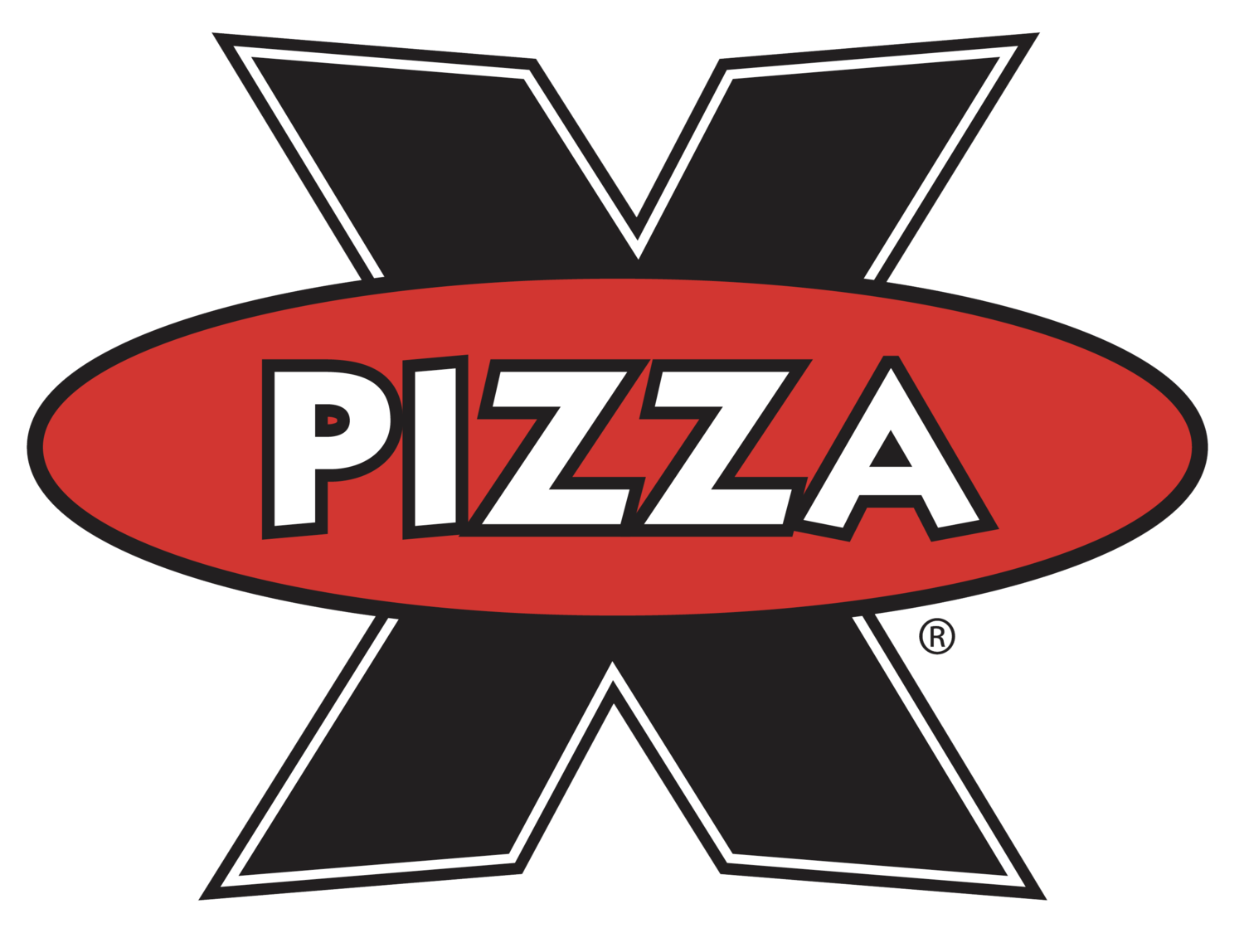

**Objective:** Every August, a fresh audience (IU freshmen) enters the market. Encourage these freshmen to buy more pizza, and therefore, more of your leading-brand pizza.

**Target Audience:** Pizza X is interested in connecting with Indiana University freshmen as they begin their college experience. Over 22,000 students are enrolled in the university’s undergraduate program as first-year students. IU students include representation from all 92 Indiana counties, all 50 states, and 170 countries globally. These students are intelligent, curious, and ambitious to earn a college degree and memories along the way. The incoming class is academically gifted with a median high-school GPA at 3.9. These students' financial status tends to cover a wide range of family incomes encompassing out-of-state tuition to Pell Grant scholarship aid.

**Current Perception:** IU freshmen know Pizza X as an infamous pizza restaurant serving up good humor and even better pizza. While every student may not have experienced the wonder of their late-night delivery services, word travels fast on a new college campus. The general consensus describes Pizza X as a popular, local pizza destination on IU Bloomington’s campus that serves quality pizza varieties to fulfill every student’s preferences.

**Single Most Compelling Message:** Pizza X offers delicious pizza to fuel late-night cravings.

**Support:**

1. **College students' bedtime isn’t at 12:00am.** College life means late-night study sessions, social gatherings, and spontaneous cravings. Pizza X understands the unique schedules of college students, where late nights are the norm, not the exception. By being available when other restaurants have closed, Pizza X aligns itself with the lifestyle of its target audience, offering the convenience and satisfaction students seek during those odd hours.

2. **Pizza X is open late hours.** Pizza X's availability into the late hours of the night, seven days a week, unlike most of its competitors, makes it perfect for students whose schedules are unpredictable and demanding. After a party, a quick bite after a late shift, or fuel for staying up all night studying for tests, Pizza X is always ready to deliver. This way, no student has to go without great pizza at any time of the day or night.

3. **Restaurant-quality pizza with fast-food efficiency.** Pizza X provides a unique balance of quality and convenience. While students might expect fast food at odd hours, Pizza X surpasses those expectations by delivering restaurant-quality pizza with the speed and efficiency they need. This combination makes it an easy choice for freshmen seeking a high-quality, tasty meal without compromising on time, especially during busy times of campus life.

**Tone:** Pizza X should maintain a witty, lively, good-humored, and established tone

**Mandatories:** Please include the following in the creative content:

Company name: Pizza X, Website: <https://www.pizzaxbloomington.com/>, Hours: Sun – Mon: 11a – 2a, Tues – Wed: 11a – 3a, Thur – Sat: 11a – 4a, Logo, and provided QR Code